South Sudan
Social Studies for PLEFS
Pupil’s Book 1

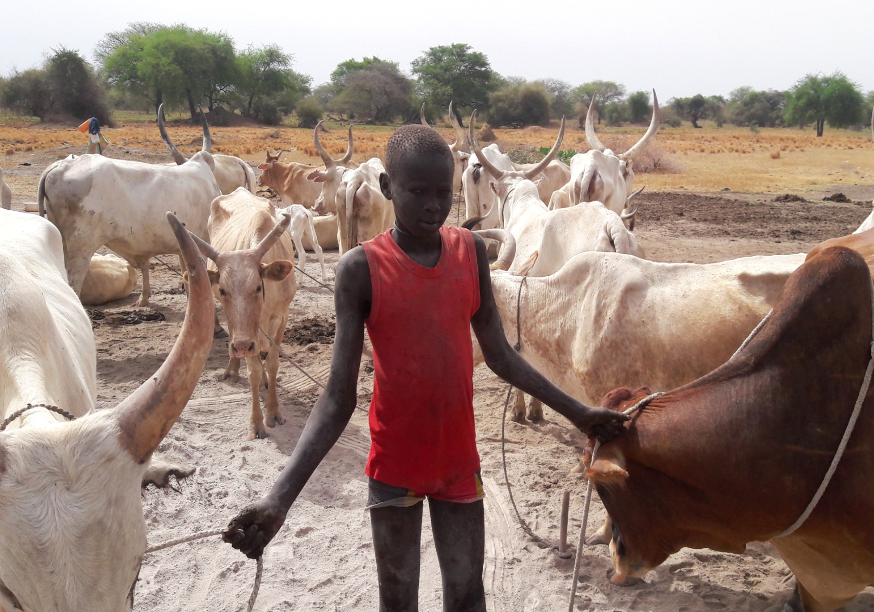

Pastoralist Livelihood and Education Field Schools (PLEFS) Approach

Contents
Unit 1: Our cattle camp home__________________________3
Unit 2: Our PLEFS___________________________________6
Unit 3: Our PLEFS surroundings________________________8
Unit 4: People in our PLEFS___________________________9
Unit 5: Our daily PLEFS activities______________________11
Unit 6: Members of our family_________________________12
Unit 7: The food we eat at the cattle camp_______________14
Unit 8: Clothes and food wear_________________________16
Unit 9: Traditional ceremonies in our family_______________19
Unit 10: Religious festivals____________________________20
Unit 11: Animals and birds that help us at home____________22

UNIT 1: OUR CATTLE CAMP HOME

Look at the picture of a cattle camp homestead
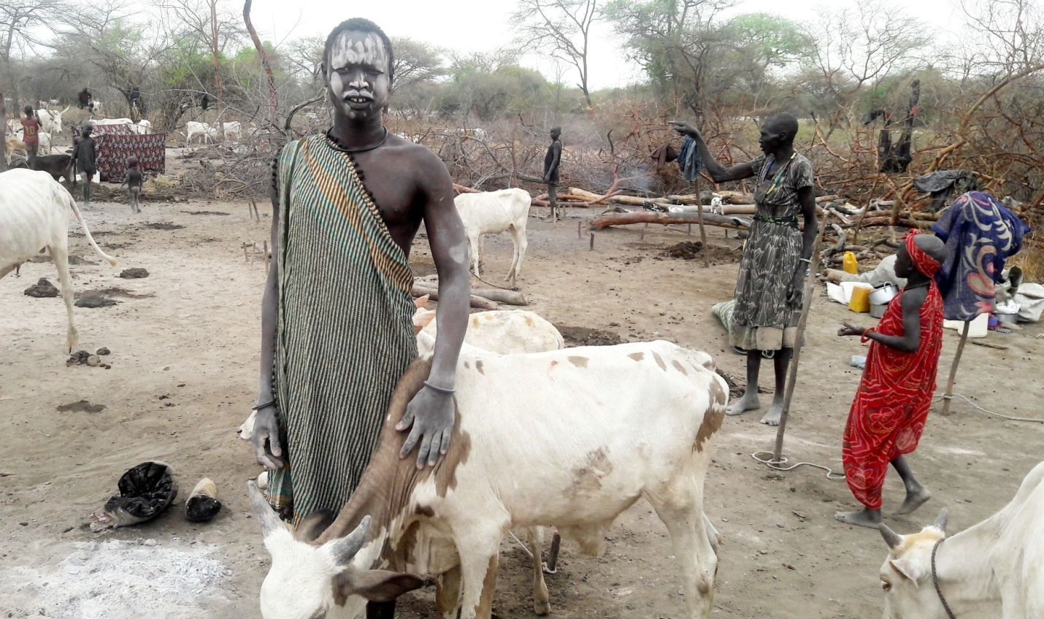

Write down the names of what see in the above picture

ACTIVITY
- Draw one of the things you see in the picture

Loo at the picture of a home in the village
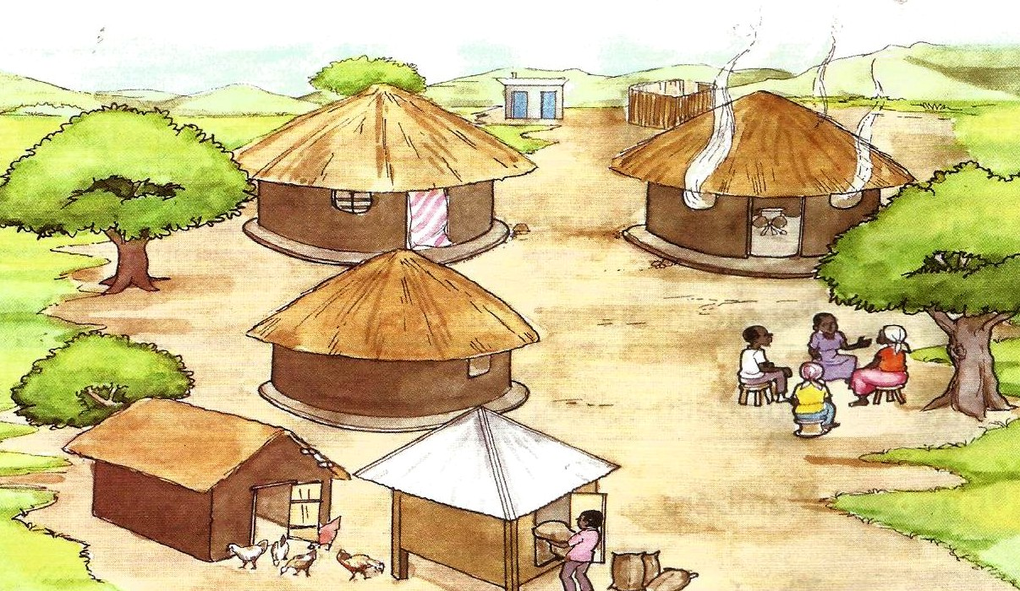
There are three small houses in the compound
There is a house where father and mother sleep
There is a children’s house
There is a kitchen house
- Point to the chicken house
- Point to the store
- Point to the pit latrine
- Point to the bathing shelter
There is also grass and some trees
- What are the walls of the houses made of?
- What are the roofs of the houses made of?

ACTIVITY
Draw one of the houses you can see in the picture

UNIT 2: OUR PLEFS

A picture of PLEFS setting
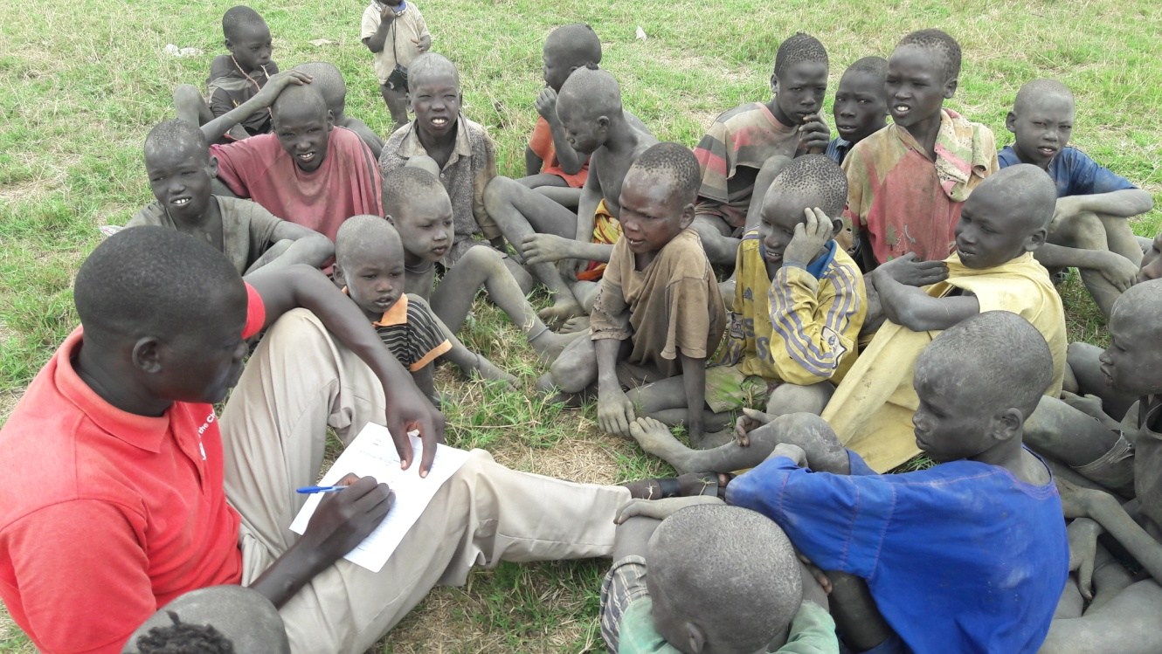

A Village school
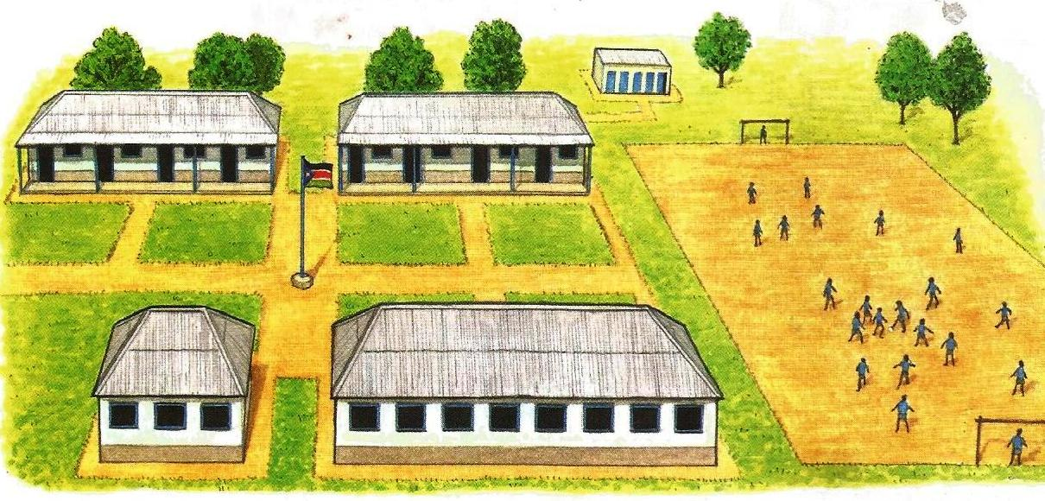
Look at the picture of the village school above
How many buildings can you see in the picture?
Can you see the classrooms in the picture?
Can you see the flag of the Republic of South Sudan?

ACTIVITY
- In groups, go outside and look at the buildings in your school compound.
- How many classrooms are there?
- Point to the head teacher’s office
- Which other buildings can you see?
- Draw a picture of your school compound or make a model of your school using clay

UNIT 3: OUR PLEFS SURROUNDING

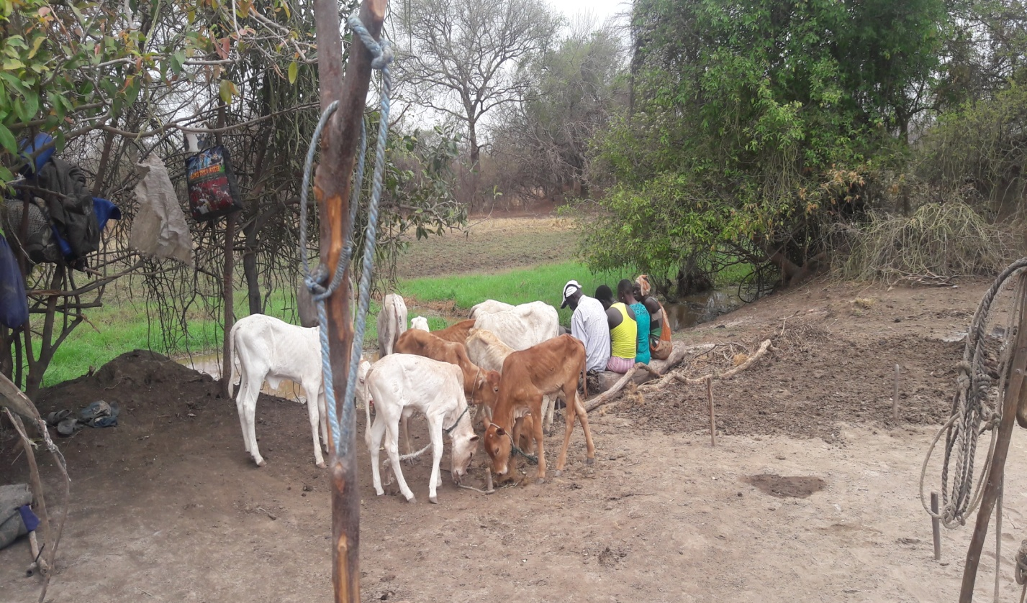

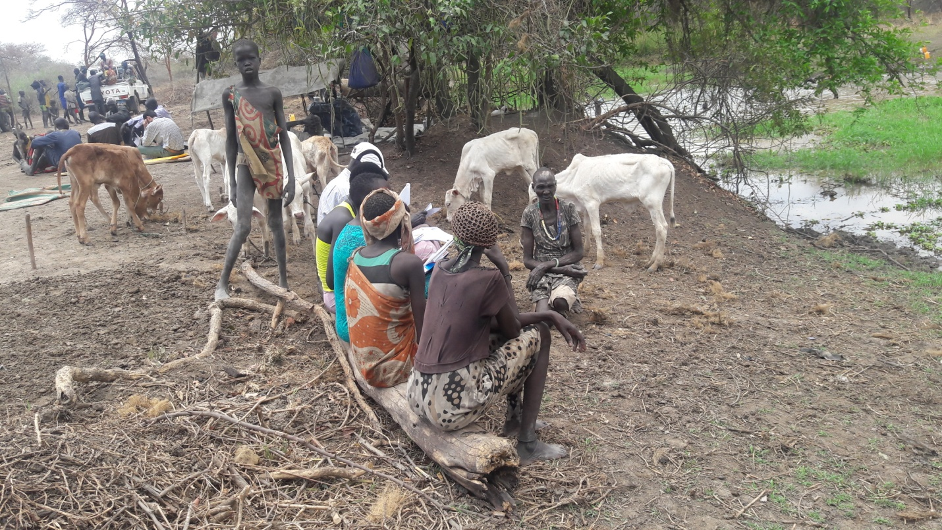
UNIT 4: PEOPLE IN OUR PLEFS

A picture of PLEFS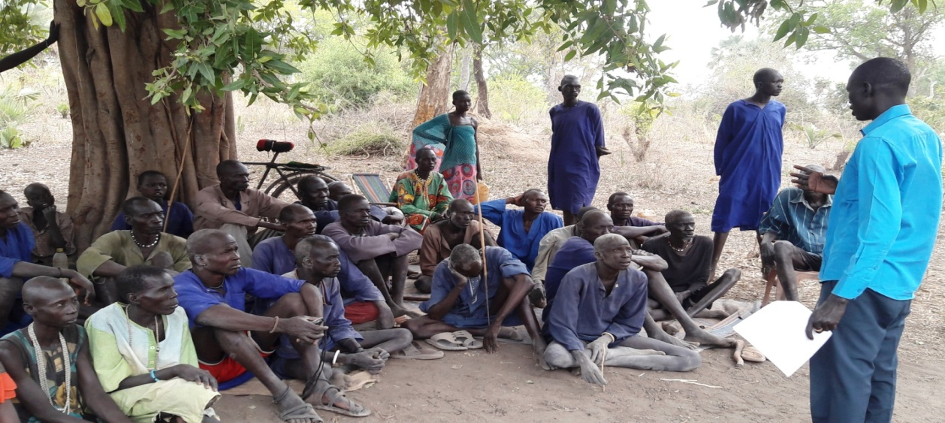

Look at the picture of a PLEFS above
How many teachers are there in the picture?
How many facilitators are there in your PLEFS?
What do your facilitators do?

ACTIVITY
- What is your facilitators name?
- Draw a picture of a facilitator teaching in a classroom

Other people who work in our PLEFS
There are other people who work together with the facilitator
Do you know what work they do?
Mention what work what work they do.

UNIT 5: OUR DAILY PLEFS ACTIVITIES

A picture of PLEFS
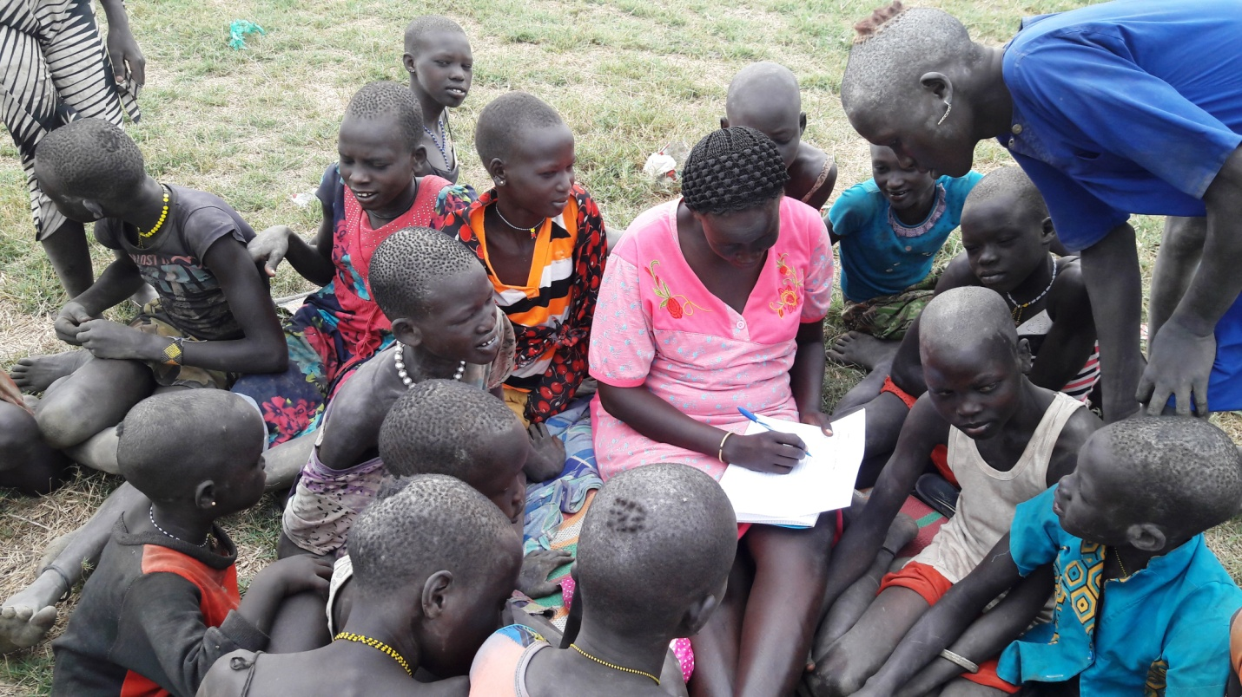
Write down what are the daily activities do in a PLEF

ACTIVITY
- In groups, talk about why it is important to have break time at PLEFS
- What do you do at break time?
- What do you do at lunch time?
- What activity do you like best during PLEFS?
- Draw a picture to show the part of the school day that you like best

UNIT 6: MEMBERS OF OUR FAMILY

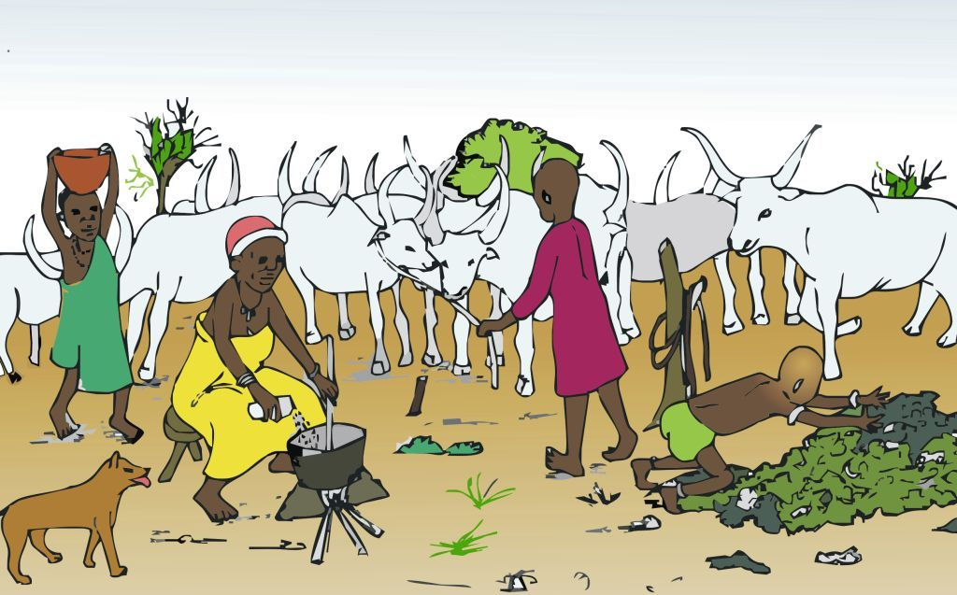
Chut and Aweng live with their parents and young brother. They are members of a family.
- The members of a family are:
- Father and mother
- Brother and sister
- Cousins
- Uncles and aunts
- Grandfather and grand mother

ACTIVITY
- Draw a picture to show how parents help their children
- Draw a picture to show how children help their parents

UNIT 7: THE TYPES OF FOOD WE EAT AT THE
CATTLE CAMP

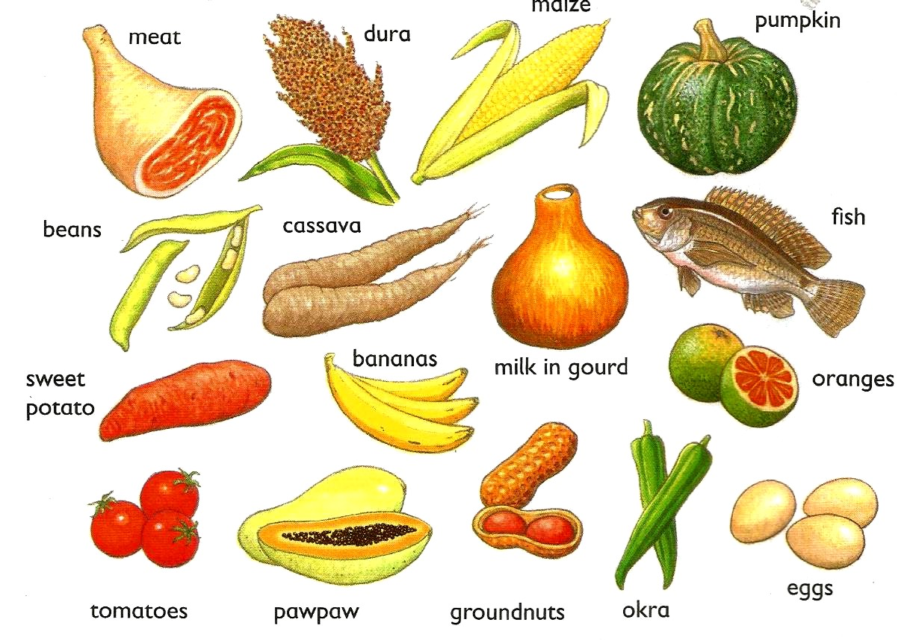

In pairs, name all the different types of foods in the pictures
Tell your friend your favorite food
Our food comes from plants and animals
Look at the picture again
Which foods come from plants?
Which foods come from animals?

ACTIVITY
- Draw one food that comes from:
- An animal, A plant

UNIT 8: CLOTHES AND FOOT WEAR

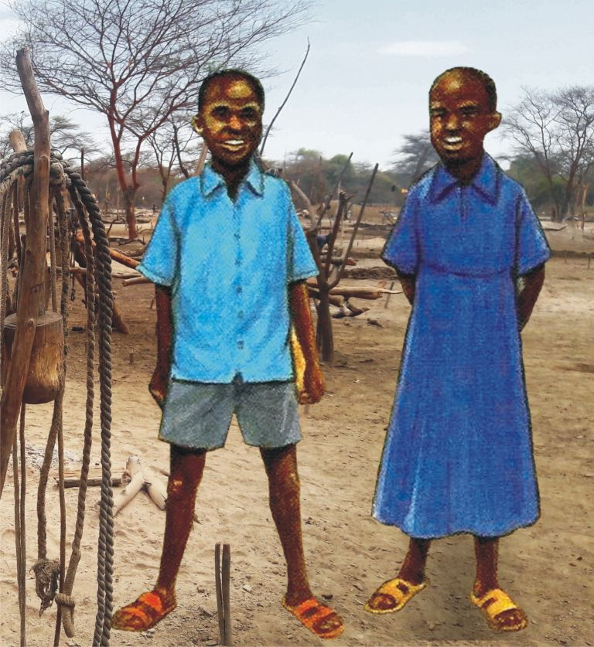
Look at the picture
Gor and Aker are wearing their school uniform.
Gor is wearing a shirt a pair of shorts.
Aker is wearing a dress.
They are both wearing sandals on their feet.
When it is hot we wear light clothes
Grandfather and grandmother in their clothes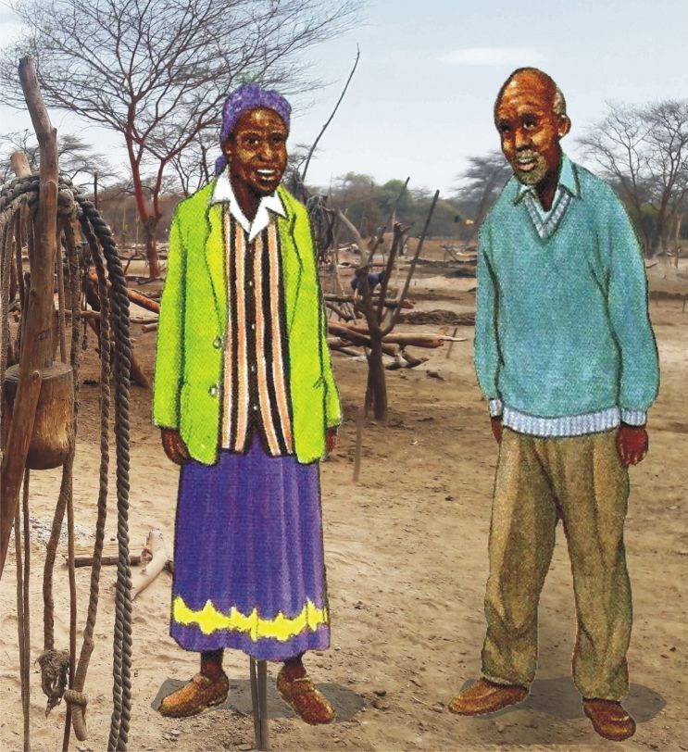
Look at the picture above
Grandfather is wearing a sweater and trousers
Grandmother is wearing a skirt and a blouse. She is also wearing a jacket.
They are both wearing shoes on their feet. When it is cold we wear warm clothes.
ACTIVITY
- In pairs, make a list of the reasons we wear clothes and shoes

UNIT 9: TRADITIONAL CEREMONIES IN OUR FAMILY

Child Naming
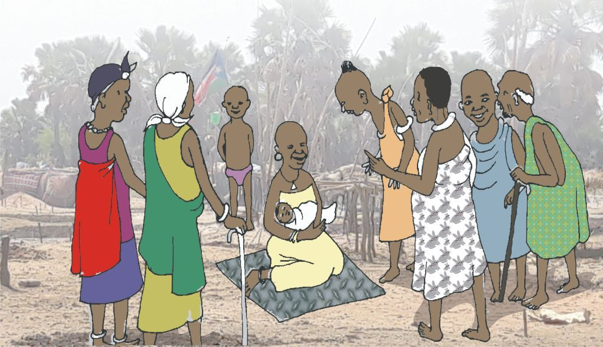
Gor and Aker’s aunt has a new baby
All the relatives and neighbors have come to the naming ceremony
The elders from the clan are there
They will give the baby a name
Everyone will have food and drinks to celebrate the naming of the baby
ACTIVITY
- Ask parents about your naming ceremony
- Write a list of our cattle camp ceremonies

UNIT 10: RELIGIOUS FESTIVALS

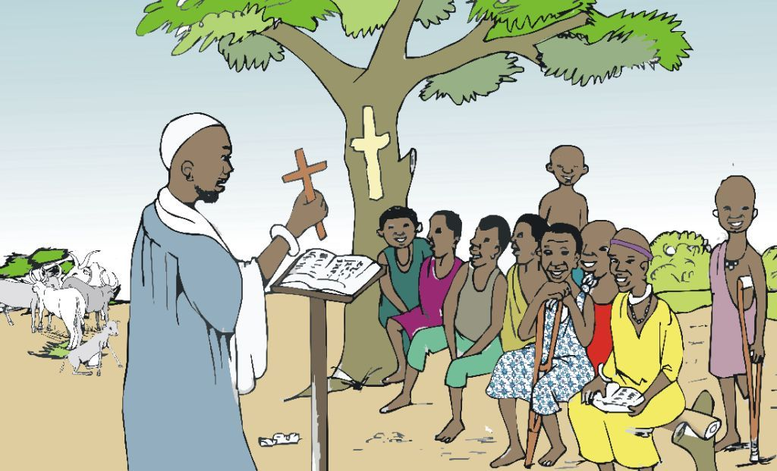
December 25th is an important day for Christians
This the day they celebrate the birth of Jesus Christ
Families go to church on Christmas Day to worship God
Sometimes people give each other gifts at Christmas
In many places, Christmas Day is a public holiday
Other important days for Christians are Good Friday and Easter Sunday.
On Good Friday, Christians remember the day when Jesus Christ died
On Easter Sunday, Christians celebrate the day when Jesus Christ rose from the dead.
ACTIVITY
- Draw a picture of people celebrating Christmas
- Write down all the religious festivals you may know from other faiths like Islam

UNIT 11:

ANIMALS AND BIRDS THAT HELP US AT
THE CATTLE CAMP

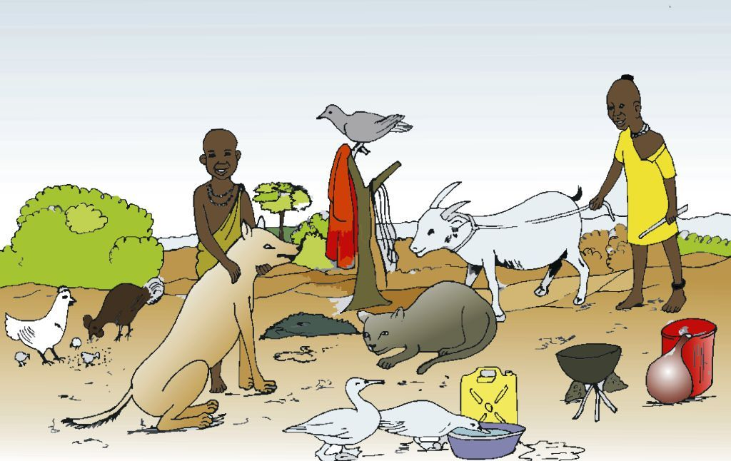
Look at the picture of the animals and birds at the cattle camp
- What are the names of the animals in the picture?
- What are the names of the names of the birds in the picture?
ACTIVITY
- In groups, say how each animal or bird helps us
- Draw a picture of one animal and one bird. Say how they help us.

